**Centralized directory service for Peer to Peer file sharing protocol**

CS5110 Project, Spring Semester 2015

Network Architecture – I

**Friday April 10, 2015**

**Motivation/Summary:**

The main objective of the project is to develop a centralized directory server for a P2P file sharing system. Usually a server responds to user’s request by sending out the required files to the users. This takes a lot of burden on the server and can affects its performance. To reduce the load on the server a centralized directory approach can be followed.

**System Architecture:**

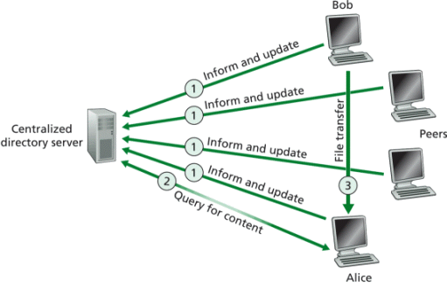

Reference: <http://www.cs.ccsu.edu/~stan/classes/CS490/CS490-FA12-project.html>

**Implementation:**

We assume that this kind of system can be used to share MP3 files among peers, just like what Napster does. As a part of testing we are using TXT files. Each peer has a unique IP address. The system consists of a number of peers and a centralized directory server. Each peer consists of a P2P client and P2P server functionality. P2P client does the following tasks such as Inform/update directory server for new files, request a peer to download a file that it is sharing. P2P server listens for incoming requests for file downloads and respond to those requests by spitting out the file in chunks. The directory server listens for incoming requests such as update directory listing or searching for a file. Therefore, this projects consists of two major parts 1) Implementation of communication between P2P client and directory server. 2) Implementation of communication between P2P client and P2P server.

A centralized directory server maintains a file called “*directory.txt*”. It consists of listing of files are currently held (Ready to share) by the peers along with peer *“IPaddress:port”.* The following diagram will explain the typical steps that are involved in file sharing.

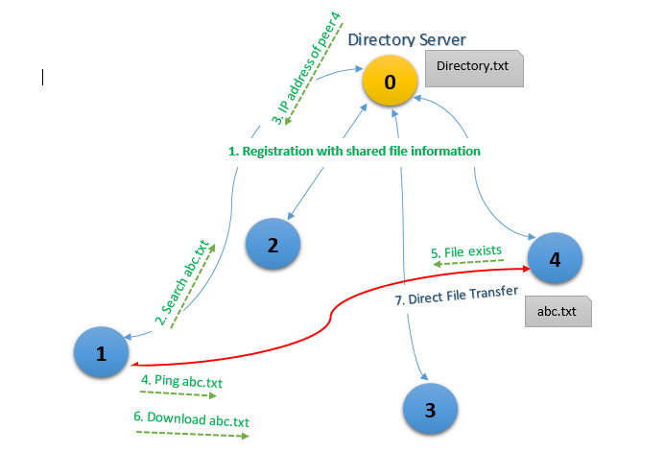

**Messages used for communication**

1. Communication between P2P client and directory server:
   1. A “*Config”* message is sent by each peer to inform/update the server with file listing. As a reply we get success message for successful update otherwise a failure message
   2. A search will send a message with “*filename: sample.txt”* to the centralized directory*.* Server replies with list of peers having the file.
2. Communication between P2P client and P2P server.
   1. A “*ping*” message is sent to all the peers having the file. As a reply from peer server *File exists/ File not exists* reaches peer client*.*
   2. A “*download”* message is sent to all the peer that has sent file exists message.

**Initial Setup to use this service:**

* IP address of the server that is to be setup in the client’s program
* Ports in between 8000 to 8200 were used. Keep them open.

**Github**: <https://github.com/rpqt7/Centralized_P2P>

Team:

Rahul Ponnada - 12448300

Anvesh Tummala - 16173144

Satish Chowdary Anumolu - 16187778